Apply filters to SQL queries

Project description
The organization is working to improve the system’s security; thus, it is my job to apply filters to SQL queries to perform security tasks. These tasks include updating employee computers and investigating potential security issues.

Retrieve after hours failed login attempts
SELECT *
FROM log_in_attempts
WHERE login_time > ’18:00:00’ AND success = FALSE;\

I used the above query to filter for failed login attempts that occurred after 18:00 to investigate a potential security incident.
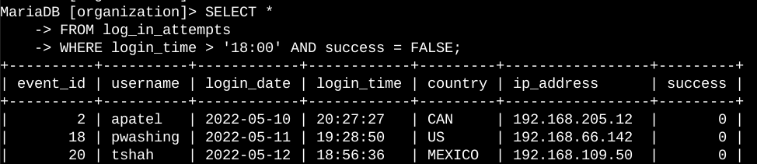

Retrieve login attempts on specific dates
SELECT *
FROM log_in_attempts
WHERE login_date = ‘2022-05-09’ OR login_date = ‘2022-05-08’;

The above query was used to retrieve login attempts on specific dates.
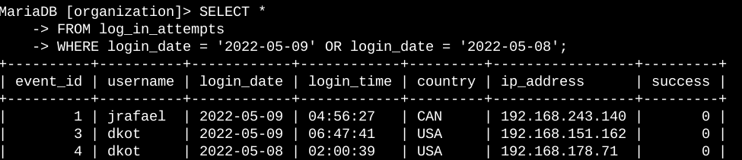

Retrieve login attempts outside of Mexico
SELECT *
FROM log_in_attempts
WHERE NOT country LIKE ‘MEX%’;

This query filters out Mexico in the result by using the LIKE filter and MEX% to represent the characters that should be omitted. I did not have to write out the whole name, but I could use the percentage symbol to represent the desired variable. The purpose of this operation was to isolate activity from outside Mexico, as there are potential issues that need to be investigated.
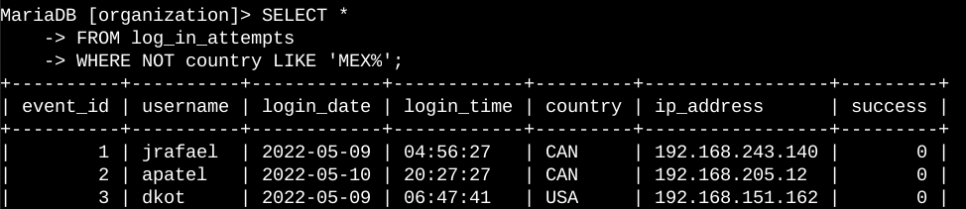

Retrieve employees in Marketing
SELECT *
FROM log_in_attempts
WHERE department = ‘Marketing’ AND office LIKE ‘East%’;

The query retrieves specific employees from a specific department using a pattern that includes the department and the office. The purpose of this operation was to update computers for specific employees in the Marketing department in offices that start with “East”.
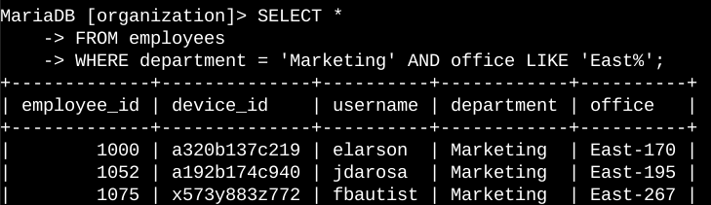

Retrieve employees in Finance or Sales
SELECT *
FROM log_in_attempts
WHERE department = ‘Sales’ OR department = ‘Finance’;

To retrieve employees from both departments, the OR function was used to filter for employees in either department. The machines for these employees need to be updated.
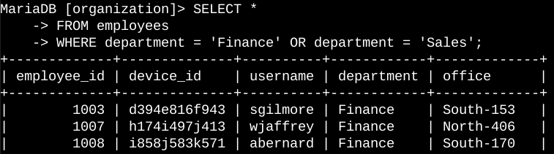

Retrieve all employees not in IT
SELECT *
FROM log_in_attempts
WHERE NOT department = ‘Information Technology’;

The team needed to make a security update for employees who aren’t in IT; the above query was used.
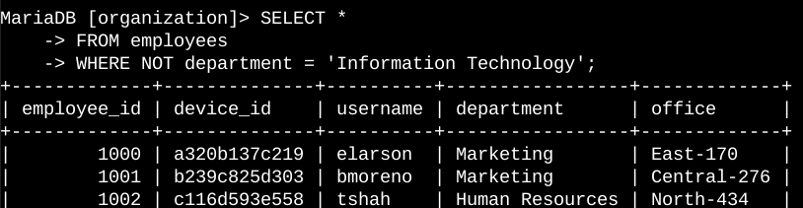

Summary
All these filters were applied to effectively query for the desired results that would assist security operations.

